# Step 1: Launch an EC2 Instance

## Log in to AWS Management Console:

* + Go to the AWS Management Console at https://aws.amazon.com/console/
  + Sign in with your AWS credentials.

## Navigate to EC2 Dashboard:

* + In the AWS Management Console, type "EC2" in the search bar and select EC2 to navigate to the EC2 Dashboard.

## Launch an Instance:

* + Click on the "Launch Instance" button.



* + Choose an Amazon Machine Image (AMI): Select "Ubuntu Server 20.04 LTS (HVM), SSD Volume Type".

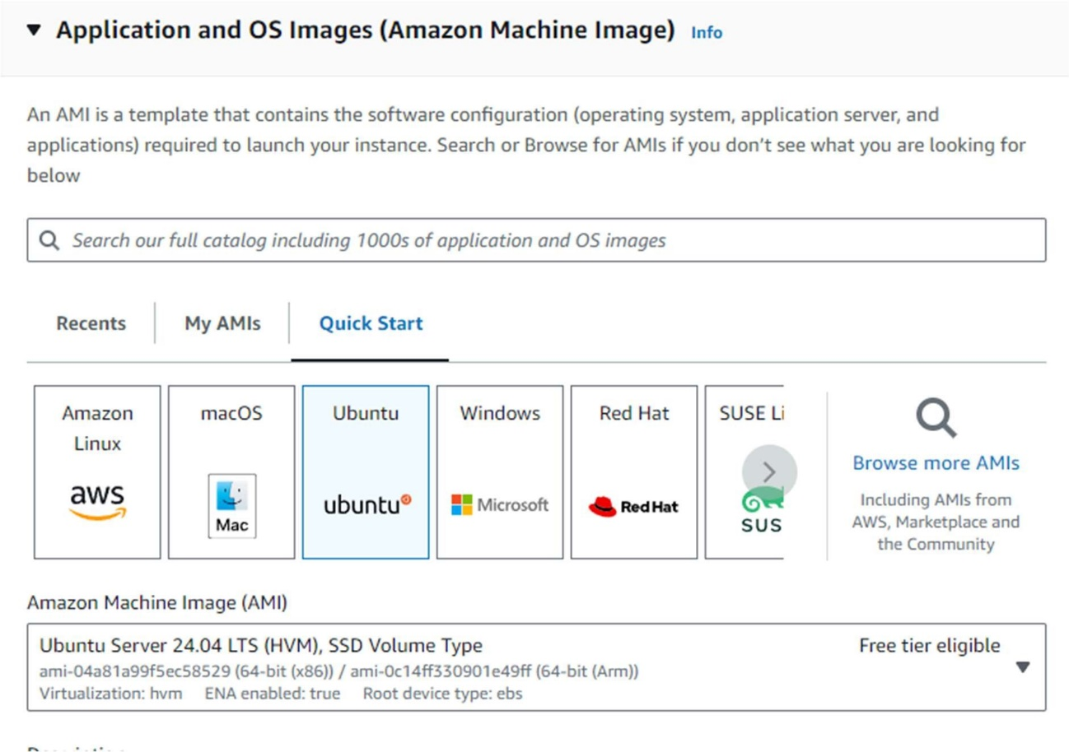

* + Choose an Instance Type: Select t2.micro (eligible for the free tier).

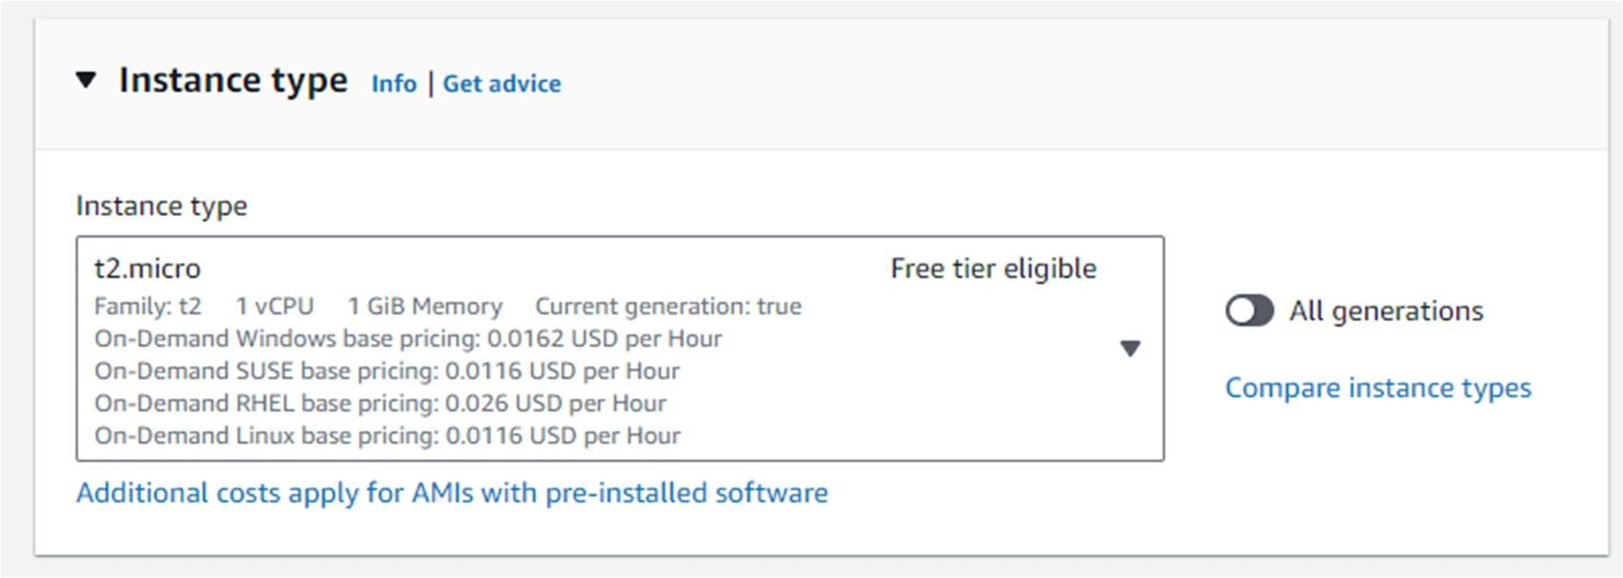

* + Configure Instance:
    - Select an existing key pair or create a new one.
    - Network: Choose the default VPC.
    - Subnet: Choose a subnet in the US-East-1 (N. Virginia) region.
    - Enable Auto-assign Public IP.

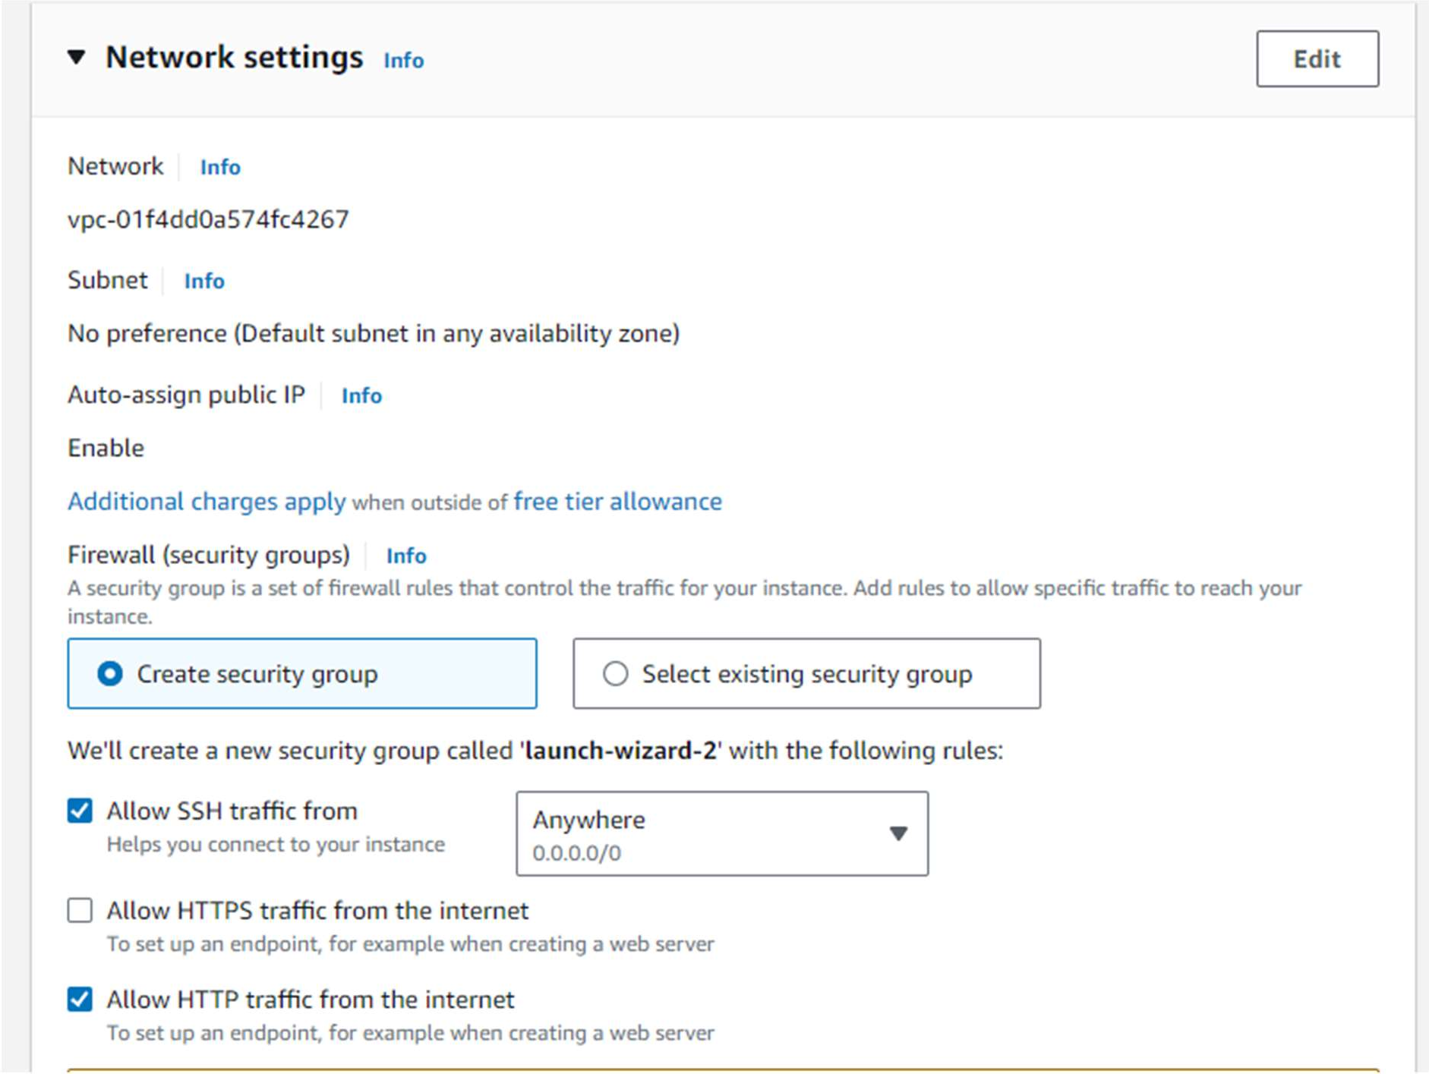

* + Add Storage: Keep the default settings.
  + Add Tags: Add a tag to identify your instance (e.g., Key: Name, Value: Nginx).

## Review and Launch:

* + Review your instance settings and click "Launch".

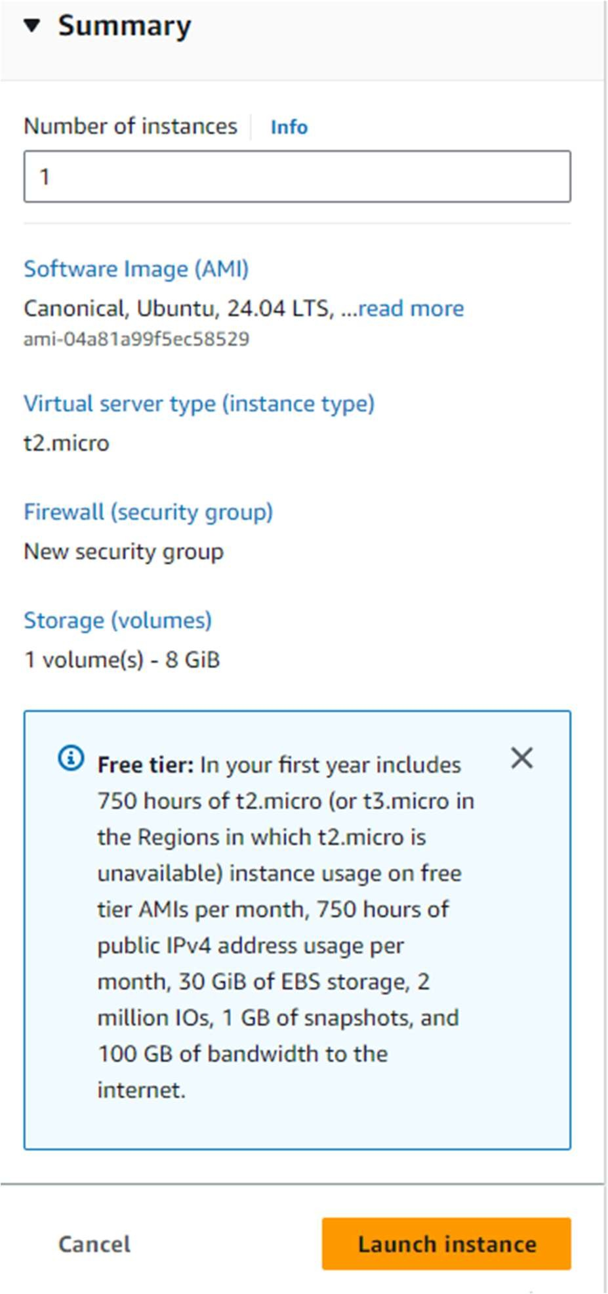



# Step 2: Create an EFS File System

## Open the EFS Console:

* + Navigate to the [EFS Console](https://console.aws.amazon.com/efs/).

## Create a New File System:

* + 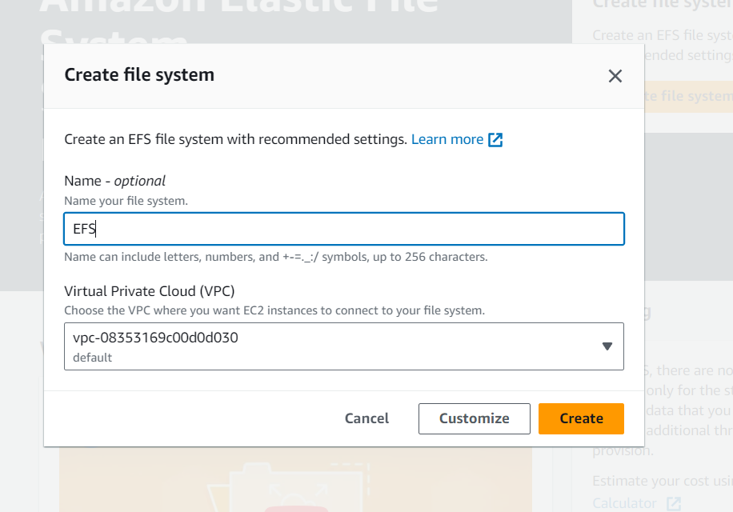Click "Create file system."
  + Select the VPC and subnets where your EC2 instances are located.
  + Click "Create."

## Create Security Group:

* + Choose the security groups that allow NFS traffic (port 2049).

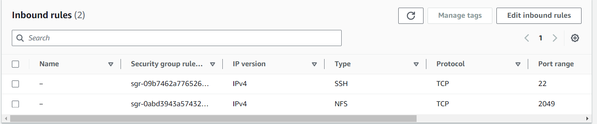

# Step 3: Connect to Your Instance

## Connect to the EC2 Instance:

* + In the EC2 Dashboard, select your instance.
  + Click on "Connect" and follow the instructions to connect to your instance using SSH.

# Step 4: Install EFS Utilities

## Update the Package List:

sudo apt-get update

## Install the EFS Mount Helper:

* + First, install the necessary dependencies:

sudo apt-get install -y nfs-common

* + Then, install the EFS mount helper:

sudo apt-get install -y amazon-efs-utils

# Step 5: Mount the EFS File System

## Create Mount Point:

sudo mkdir /mnt/efs

## mount using the file system DNS name::

sudo mount -t efs -o tls *file-system-dns-name* *efs-mount-point*/

sudo mount -t efs -o tls fs-0a137bc31c19bad5b.efs.us-east-1.amazonaws.com /mnt/efs/

1. **Verify the Mount**

df -h